Stat405 Bayesian Project - Aiwei Yang42274209 Chang Sun19062439
- Introduction
Bike-sharing systems have become an important part of urban transportation in several cities. They provide a flexible and environmental-friendly way of people to travel, especially for short distances. Understanding what factors influence bike usage can help improve system management and planning.
In this project, we use a real-world dataset of hourly bike rentals in London. The dataset includes the number of bike rentals as well as information on weather conditions, such as temperature. humidity, wind speed and indicators for weekends and time trends.
Our goal is to study how these factors affect bike rental demand. In particular, our research question is How do weather conditions (temperature, humidity, windspeed) and time-related factors (weekends/weekdays) affect influence hourly bike rental demand in London. To do this, we build Bayesian models and estimate the posterior distribution of model parameters. This allows us to quantify both the effects of the variables and the uncertainty in our estimates.
- Exploratory Data Analysis
The dataset contains hourly observations of bike rental demand in London between 2015 and 2017. The response variable cnt represents the number of bike rentals per hour, with values ranging from 0 to 7860 and an average of approximately 1143 rentals per hour.
The distribution of cnt is highly right-skewed as shown in the histogram. Most observations are concentrated at lower values, with a long tail extending toward higher rental counts. This skewness suggests that a Poisson model may be appropriate.
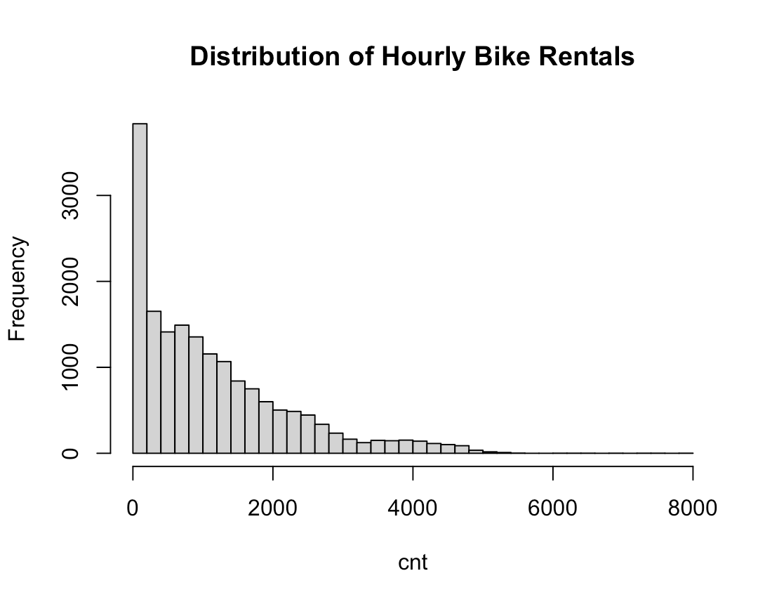
Fig.1
We examined the relationships between bike rentals and several key predictors. The scatter plot of temperature(t1) and bike rentals shows a clear positive relationship which indicating that higher temperatures are associated with increased demand. In contrast, humidity(hum) appears to have a negative association with bike rentals, as higher humidity levels correspond to lower counts. Wind speed also shows a weak negative relationship with bike rentals.
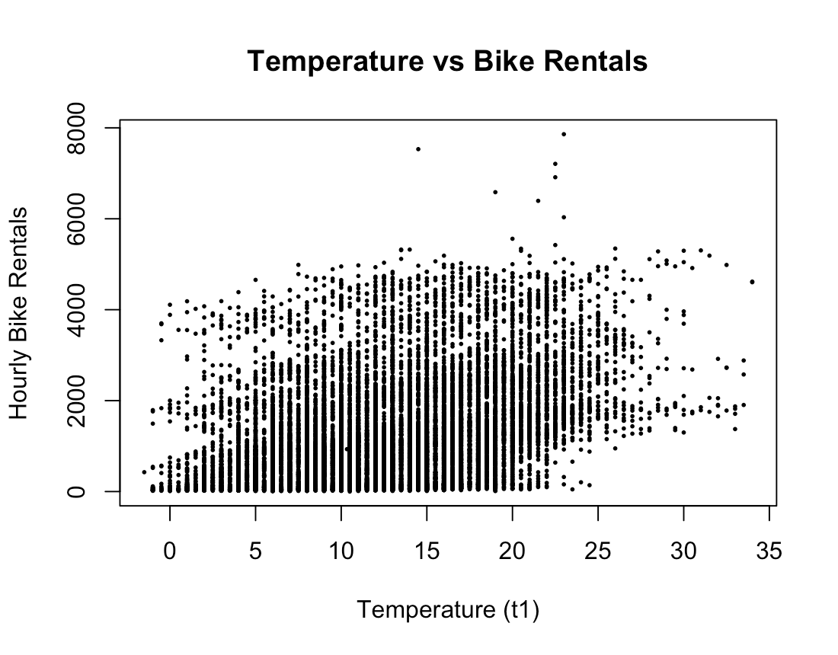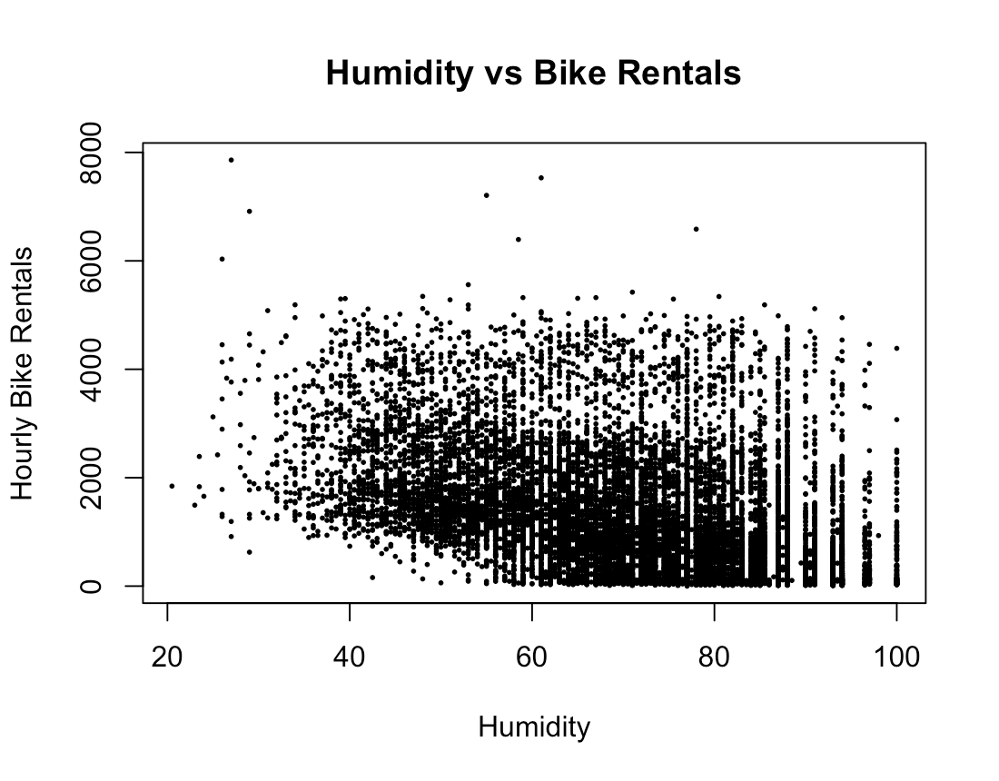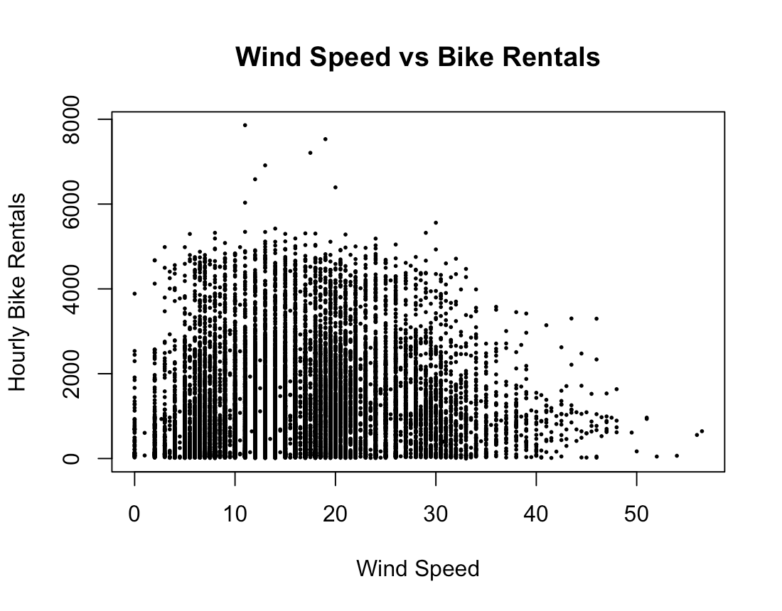
Fig.2 Fig.3 Fig.4
Additionally, the boxplot comparing weekdays and weekends suggests that bike rental demand tends to be slightly lower on weekends than on weekdays which indicating that commuting patterns may be an important role in driving demand.
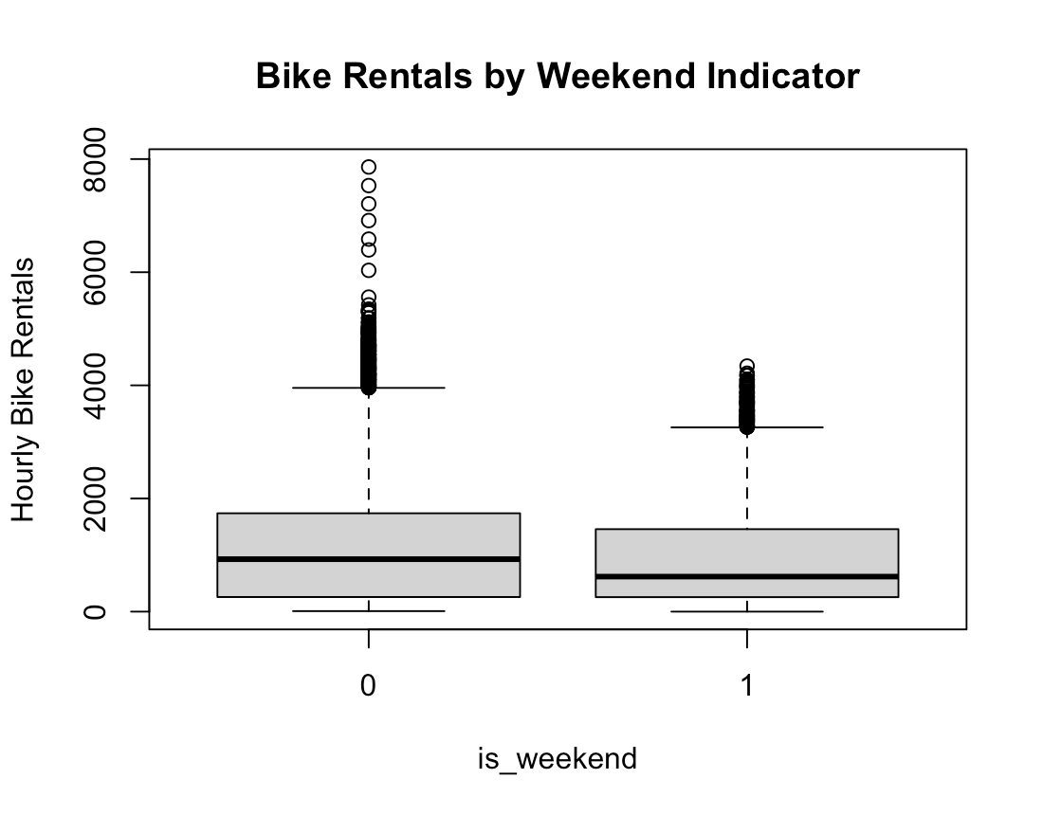
Fig.5
- GLM sanity check
For the GLM check, we estimated a Poisson regression model using maximum likelihood to verify the direction and significance of the predictors. The results show that temperature (t1) has a strong positive effect on bike rental demand, while humidity (hum) has a strong negative effect. The weekend indicator (is_weekend) is also negative which suggesting that demand is lower on weekends compared to weekdays.
Wind speed shows a small positive coefficient which may reflect interactions with other weather conditions or the fact that moderate wind speeds do not strongly discourage cycling.
Overall, all coefficients are statistically significant and these results are consistent with the patterns observed in the EDA and support the use of Bayesian Poisson regression model with these predictors. We can also see that the magnitude of z-values is extremely large which suggest a very strong signal in the data due to the large sample size.
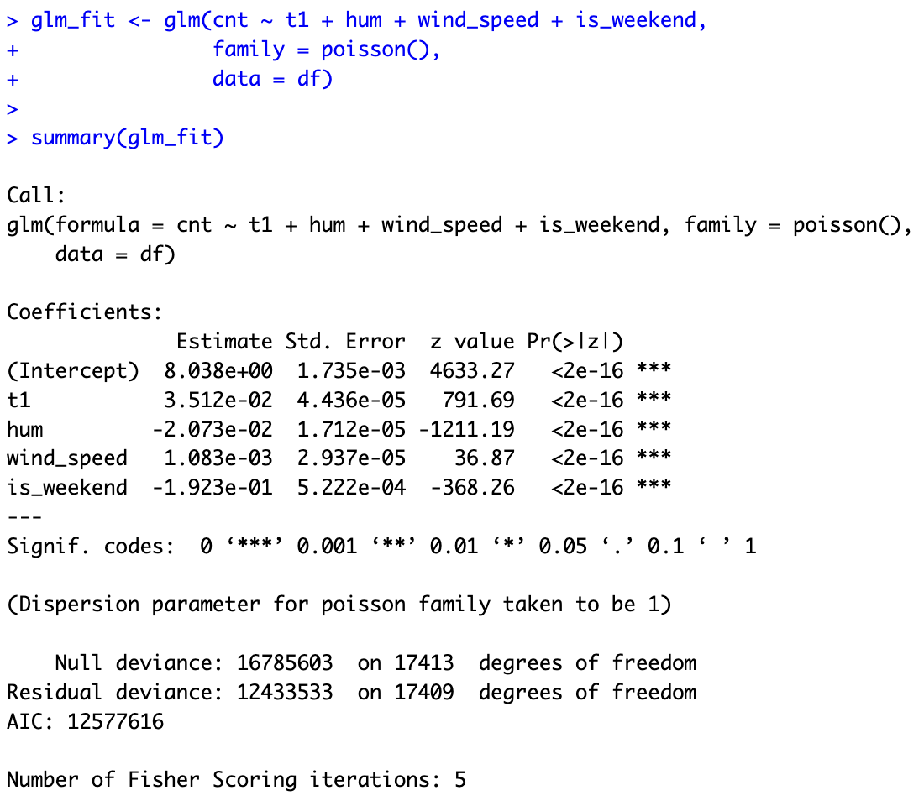
Fig.6
- Bayesian Models
The Poisson model is a appropriate choice for this problem because the response variable represents hourly bike rental counts which are non-negative integers. So we consider two Bayesian models to analyze bike rental counts. The first is a simple baseline model that assumes a constant rate across all observations. The second is a Poisson regression model that incorporates weather and temporal covariates.
- Baseline Model: For the first model, we begin with a simple baseline model in which bike rental counts are assumed to follow a Poisson distribution with a constant rate:
$${\text{y}}_{\text{i}}\text{ \sim Poisson(λ)}$$
We place a Gamma prior on the rate parameter:
$$\text{λ}\text{ \sim }\text{Gamma}\text{(}\text{a}\text{,}\text{b}\text{)}$$
Due to conjugacy, the posterior distribution is:
$$\text{λ}\text{|}\text{y}\text{ \sim }\text{Gamma}\text{(}\text{a}\text{+∑}{\text{y}}_{\text{i} }\text{, }\text{b}\text{+}\text{n}\text{)}$$
This model ignores all covariates and serves as a baseline for comparison. It also provides a useful reference point for validating the implementation for more complex model (model 2).

- Bayesian Poisson Regression Model: To account for effects of weather and time-related variables, we consider a Poisson regression model:
$${\text{y}}_{\text{i}}\text{ \sim }\text{Poisson}\text{(}{\text{λ}}_{\text{i}}\text{)}$$
$$\text{log}\text{(}{\text{λ}}_{\text{i}}\text{) = }{\text{β}}_{\text{0}}\text{ + }{\text{β}}_{\text{1}}\text{t}{\text{1}}_{\text{i}}\text{ + }{\text{β}}_{\text{2}}{\text{h}\text{um}}_{\text{i}}\text{ + }{\text{β}}_{\text{3}}{\text{wind}\text{_}\text{speed}}_{\text{i}}\text{ + }{\text{β}}_{\text{4}}{\text{is}\text{_}\text{weekend}}_{\text{i}}$$
We assume independent normal priors:
$${\text{β}}_{\text{j}}\text{ \sim }\text{N}\text{(0,10), }\text{j}\text{=0,...,4}$$
The posterior distribution is given by:
$$\text{p}\text{(}\text{β}\text{|}\text{y}\text{)∝}\text{p}\text{(}\text{y}\text{|}\text{β}\text{)}\text{p}\text{(}\text{β}\text{)}$$
The log-posterior can be written as:
$$\text{log p}\text{(}\text{β}\text{|}\text{y}\text{) }\text{=}\sum_{i}{\text{[}{\text{y}}_{\text{i}}{\text{X}}_{\text{i}}\text{β}\text{ − }\text{exp}\text{(}{\text{X}}_{\text{i}}\text{β}\text{)] −}\sum_{\text{j}}{\frac{{\text{β}}_{\text{j}}^{\text{2}}}{\text{2}\text{·}{\text{10}}^{\text{2}}}} }$$
This model allows us to capture how environmental and temporal factors influence bike demand.
Prior Justification: For the regression model, we use normal priors:
$$β_{j} \sim N(0, 10)$$
This choice means we do not assume strong effects from the variables before seeing the data. At the same time, t avoids extremely large values that are not realistic.
For the baseline model, we use a Gamma prior for the rate parameter. This choice makes the model easy to compute and give us a clear reference point for checking our results. Given the large sample size, the posterior inference is expected to be less dependent on the prior.

